IBM SkillsBuild
Student Portal

User Manual
Sprint 2 — Checkpoint 2
Version 2.0 · March 2026

Table of Contents

1. Introduction 3
2. Getting Started 3
2.1 System Requirements 3
2.2 Accessing the Portal 3
3. Creating an Account 4
4. Logging In 5
5. Homepage 6
6. Student Dashboard 7
6.1 Progress Statistics 7
6.2 Current Goal 7
6.3 Starting a Course 8
6.4 Marking a Course as Complete 8
7. My Profile 9
7.1 Updating Your Details 9
7.2 XP, Levels & Titles 10
7.3 Achievements 10
8. Leaderboard 11
8.1 Global Rankings 11
8.2 Friends Rankings 12
9. Friends 12
9.1 Viewing Your Friends 12
9.2 Discovering & Adding People 13
9.3 Removing a Friend 13
10. Logging Out 14
11. Troubleshooting 14

1. Introduction
The IBM SkillsBuild Student Portal is a gamified web application that helps university students track, and complete IBM SkillsBuild online courses. Students earn Experience Points (XP) by completing courses and logging in daily, which increases their Level and Streak. A Friends system lets students connect with other learners. A dual-mode Leaderboard shows both global and friends-only rankings. Profile Titles are cosmetic rewards that can be earned and equipped to personalise your display on the leaderboard.

This user manual covers every feature delivered in Sprint 2. It is intended for all registered students and provides step-by-step instructions for every page of the portal, illustrated with annotated screenshots.

2. Getting Started

2.1 System Requirements
Requirements
- A modern web browser: Google Chrome, Mozilla Firefox, or Microsoft Edge (latest version).
- A stable internet connection.
- JavaScript must be enabled in your browser (enabled by default in all major browsers).

2.2 Accessing the Portal
Open your web browser and navigate to the URL provided by your system administrator or module tutor (e.g. http://localhost:8080 in a local development environment). The Login page will load automatically.

ℹ️ Note
If the page does not load, confirm the application server is running and your internet connection is active. Refresh the page with F5 or Ctrl+R.

3. Creating an Account
New users must register before accessing the portal. Registration is free and takes under a minute.

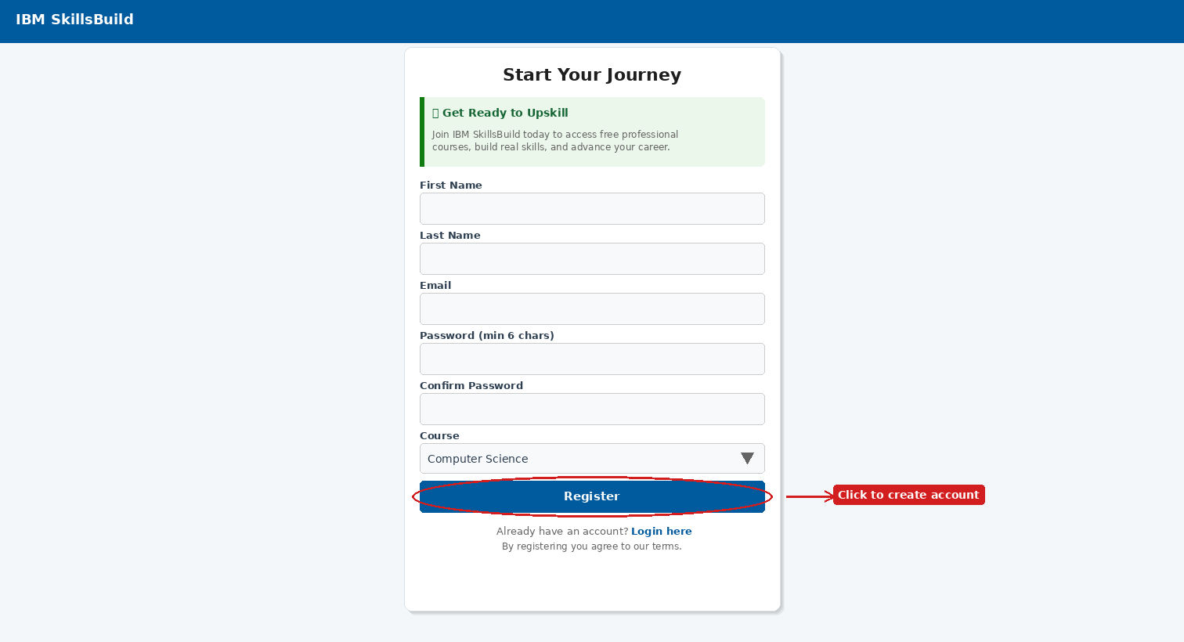
Figure 1 – Start Your Journey — Create Account page

# | Action
1 | Navigate to the portal URL in your browser. The Login page will appear.
2 | Click the Register here link at the bottom of the login card. The Create Account page shown above will open.
3 | Read the Get Ready to Upskill information panel, then complete the form fields described in steps 4–9.
4 | First Name – Enter your given (first) name.
5 | Last Name – Enter your family (last) name.
6 | Email – Enter a valid email address. This is what you will use to log in.
7 | Password – Choose a password of at least 6 characters.
8 | Confirm Password – Re-type the same password to confirm it.
9 | Course – Select your degree programme from the dropdown (e.g. Computer Science, Artificial Intelligence).
10 | Click the blue Register button to submit the form.
11 | If registration is successful you will be redirected to the Login page. If an error appears, correct the highlighted field and try again.

✅ Tip
Your email and password are case-sensitive. There is no self-service password-reset in this version, so store your credentials safely.

4. Logging In
Once registered, you can log in at any time to access all features of the portal.

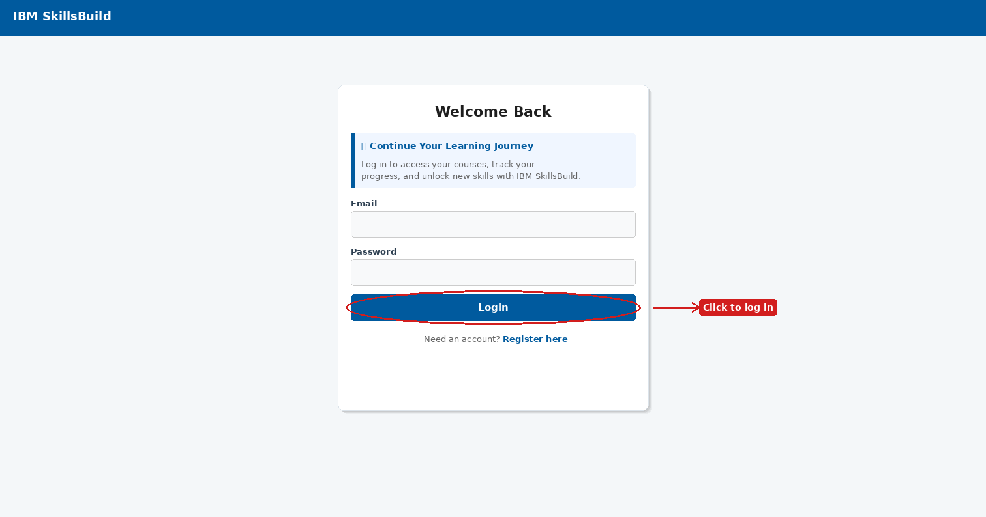
Figure 2 – Welcome Back — Login page

# | Action
1 | Open the portal URL. The Login page shown above will appear.
2 | Enter your registered Email address in the Email field.
3 | Enter your Password in the Password field.
4 | Click the blue Login button.
5 | If your credentials are correct you will be taken to the Homepage.
6 | If the error message "Invalid email or password" appears, check for typing errors and try again.

⚠️ Important
If you cannot log in and believe your credentials are correct, contact your system administrator. Self-service password reset is not available in this version.

5. Homepage
After logging in you are taken to the Homepage. It gives a personalised summary of your current progress and quick access to recently started courses.

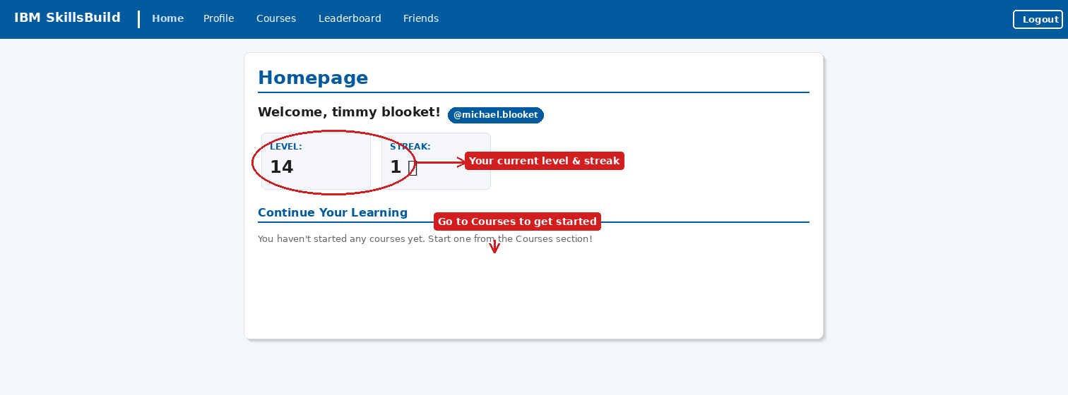
Figure 3 – Homepage showing Level, Streak and Continue Your Learning

Element | What it means
Level | Your current level, calculated from your accumulated XP. Increases as you earn more XP.
Streak | The number of consecutive days you have logged in. Maintaining a streak earns bonus XP.
@username badge | Your unique username displayed beside your name, also visible on the leaderboard.
Continue Your Learning | Shows any courses you have already started. Click a course to continue it directly.

Use the navigation bar at the top of every page to move between sections: Home, Profile, Courses, Leaderboard, and Friends.

✅ Tip
Log in every day to maintain your streak and earn daily login achievements that award bonus XP.

6. Student Dashboard
Click Courses in the navigation bar to open the Student Dashboard. This is your main workspace for managing IBM SkillsBuild courses. It is organised into four areas: the progress hero card, the Current Goal tracker, Started Courses, Available Courses, and Completed Courses.

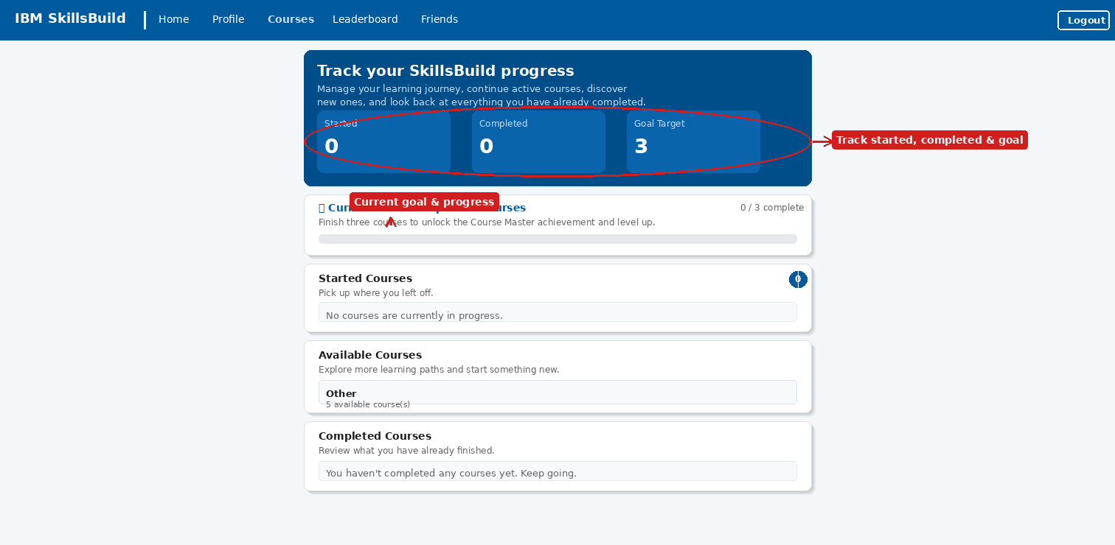
Figure 4 – Student Dashboard with hero stats, goal tracker and course sections

6.1 Progress Statistics
The blue hero card at the top of the Dashboard shows three live counters:

Stat | Description
Started | The number of courses you are currently working through.
Completed | The total number of courses you have marked as complete.
Goal Target | The number of courses required to complete your current goal (default: 3).

6.2 Current Goal
Directly below the hero card is the Current Goal card. It shows your active challenge, a progress counter (e.g. 0 / 3 complete), and a progress bar that fills as you complete courses. Completing the goal unlocks the Course Master achievement and awards bonus XP.

6.3 Starting a Course
# | Action
1 | On the Dashboard, scroll to the Available Courses section.
2 | Click on a course category (e.g. "Other") to expand it and see the individual courses inside.
3 | Click the blue View Details button on a course card to preview the content on the IBM SkillsBuild website.
4 | Click the green Start Course button on a course card to enrol. The course immediately moves to your Started Courses section.

6.4 Marking a Course as Complete
# | Action
1 | Scroll to the Started Courses section on the Dashboard.
2 | Find the course you have finished on the IBM SkillsBuild website.
3 | Click the green Mark as Complete button on that course card.
4 | The course moves to Completed Courses, your Completed counter increments, and XP is added to your profile.

✅ Tip
After completing a course, check your Profile page — new achievements may have been unlocked automatically.

7. My Profile
Click Profile in the navigation bar to open your Profile page. This page shows your XP progress, lets you update personal details, and displays all your earned achievements and available titles.

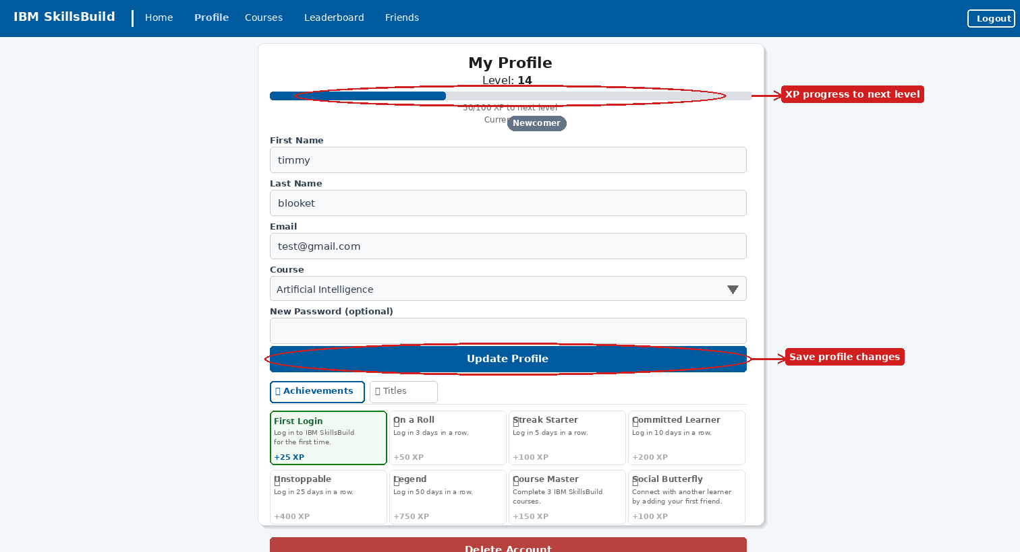
Figure 5 – My Profile page with XP bar, achievements grid and Titles tab

7.1 Updating Your Details
# | Action
1 | Navigate to Profile in the top navigation bar.
2 | Edit the fields as needed: First Name, Last Name, Email, Course.
3 | To change your password, type a new one in the New Password (optional) field. Leave it blank to keep your current password.
4 | Click the blue Update Profile button to save. A confirmation message will appear if the update is successful.

⚠️ Important
Leave the New Password field blank if you do not want to change your password. Filling it in will replace your existing password immediately.

7.2 XP, Levels & Titles
At the top of your Profile page you will see your current Level, an XP progress bar showing how close you are to the next level, and your active Title badge (e.g. Newcomer). The XP bar displays your current XP out of the amount needed for the next level.

Term | Description
XP (Experience Points) | Earned by completing courses, logging in daily, and unlocking achievements.
Level | Increases automatically as you accumulate XP. Your level is visible on the homepage and leaderboard.
Title | A cosmetic badge displayed next to your username on the leaderboard. Equip a title from the Titles tab.
Streak | Consecutive login days. Increases your XP multiplier and can unlock streak-based achievements.

To equip a different title, click the Titles tab on the Profile page, find an unlocked title, and click the Equip button next to it. Your title will update immediately on the leaderboard.

7.3 Achievements
The Achievements tab (default) shows a grid of all available achievements. Unlocked achievements are highlighted with a green border; locked ones show a padlock icon. Each achievement card lists its name, how to earn it, and the XP reward.

Achievement | How to earn it
First Login | Log in to IBM SkillsBuild for the first time. +25 XP
On a Roll | Log in 3 days in a row. +50 XP
Streak Starter | Log in 5 days in a row. +100 XP
Committed Learner | Log in 10 days in a row. +200 XP
Unstoppable | Log in 25 days in a row. +400 XP
Legend | Log in 50 days in a row. +750 XP
Course Master | Complete 3 IBM SkillsBuild courses. +150 XP
Social Butterfly | Add your first friend. +100 XP
Trendsetter | Equip a custom title for the first time. +75 XP

⚠️ Warning
The Delete Account button at the bottom of the Profile page permanently removes your account and all data. This action cannot be undone.

8. Leaderboard
Click Leaderboard in the navigation bar to view rankings. The Leaderboard has two tabs: Global (all registered students) and Friends (only students you have added as friends).

8.1 Global Rankings

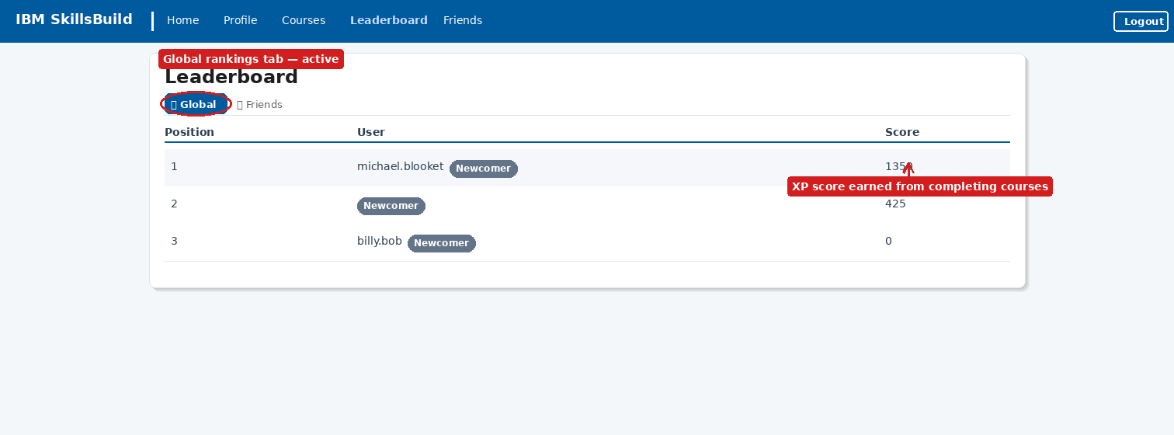
Figure 6 – Leaderboard — Global tab showing all students ranked by XP

# | Action
1 | Click Leaderboard in the navigation bar. The Global tab is shown by default.
2 | The table displays each student’s Position, Username with their Title badge, and XP Score.
3 | Find your own row to see where you rank among all registered students.
4 | To improve your position, earn more XP by completing courses, logging in daily, and unlocking achievements.

8.2 Friends Rankings

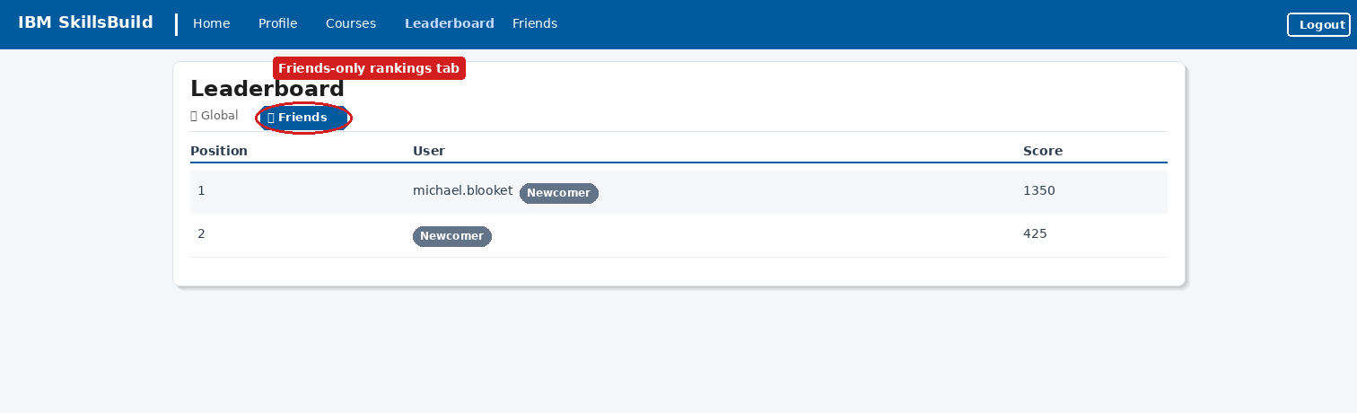
Figure 7 – Leaderboard — Friends tab showing only connected learners

# | Action
1 | On the Leaderboard page, click the Friends tab.
2 | The table updates to show only students you have added as friends.
3 | Use this view to compare your progress with a smaller, more personal group.
4 | If no friends appear, navigate to the Friends page to add some.

ℹ️ Note
Leaderboard scores are refreshed each time the page loads. XP changes appear immediately after completing a course or unlocking an achievement.

9. Friends
The Friends feature allows you to connect with other learners, compare progress on the Friends Leaderboard, and unlock the Social Butterfly achievement.

9.1 Viewing Your Friends

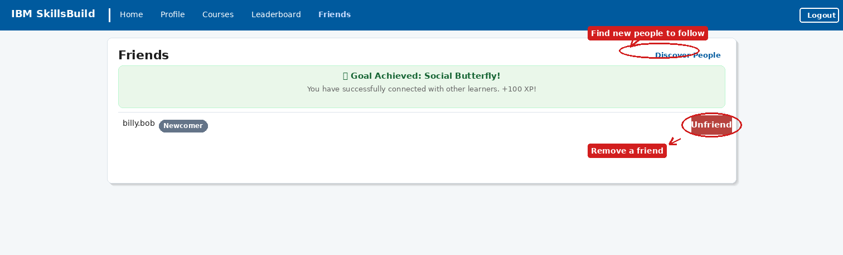
Figure 8 – Friends page showing Social Butterfly goal achieved and a connected friend

Click Friends in the navigation bar to open the Friends page. Each friend is listed with their username and current Title badge. Once you have added at least one friend, the Social Butterfly goal banner appears at the top of the page, confirming you have earned +100 XP.

ℹ️ Note
The Friends page also shows a goal prompt if you have not yet added anyone: "Current Goal: Add a Friend". Adding your first friend completes this goal and awards 100 XP automatically.

9.2 Discovering & Adding People
# | Action
1 | On the Friends page, click the Discover People link in the top-right corner of the page card.
2 | The Discover page loads, showing a list of all registered students.
3 | Use the search box and Search button to filter students by username.
4 | Find the person you want to add and click the green Friend button in their row.
5 | The button changes to red Unfriend, confirming the connection. Return to the Friends page to see them in your list.

9.3 Removing a Friend
# | Action
1 | Go to the Friends page or the Discover People page.
2 | Find the friend you want to remove.
3 | Click the red Unfriend button in their row.
4 | The friend is removed from your list immediately. They will no longer appear on your Friends Leaderboard.

10. Logging Out
Always log out when you have finished using the portal, particularly on shared or public computers.

# | Action
1 | Click the Logout button in the top-right corner of the navigation bar (visible on every page after login).
2 | Your session is ended securely and you are returned to the Login page.
3 | To use the portal again, log in with your email and password as described in Section 4.

⚠️ Security Reminder
Do not leave the portal open and unattended. Always click Logout when finished to protect your account and prevent others from earning XP under your name.

11. Troubleshooting
If you encounter a problem, refer to the table below.

Problem | Solution
Page does not load | Check the server is running and your internet connection is active. Press F5 to refresh.
"Invalid email or password" | Email and password are case-sensitive. Check for typos. Contact your administrator if the issue persists.
Registration fails | Ensure all fields are filled, both password fields match, and the password is at least 6 characters. Use an email not already registered.
Courses not appearing | Click the refresh / expand control in the Available Courses section. Check your internet connection.
XP not updated after completion | Ensure you clicked Mark as Complete on the Dashboard. Completing the course on IBM SkillsBuild alone does not update the portal.
Achievement not awarded | Achievements are granted automatically. Check the Achievements tab on your Profile page; the unlock may already be listed.
Friend not appearing after adding | Return to the Friends page. If the issue persists, try refreshing the page or logging out and back in.
Cannot change password | Ensure you fill in the New Password field, not just the other fields. Check the field is not blank before clicking Update Profile.
Streak not increasing | Streaks increment once per calendar day. Logging in multiple times on the same day counts as one day.

IBM SkillsBuild Student Portal · User Manual · Sprint 2 · v2.0 · March 2026

